**Volunteer Requirements**

*Walkerville Primary School values and celebrates strong, positive connections with parents and families and one way to do this is by being a volunteer. Supporting our children in the classroom, on excursions and camps, with sport activities, fundraising or special events or by joining a committee are all ways we rely on the goodwill, expertise and care of our volunteers*.

All volunteers in Department for Education schools must complete the following;

* Volunteer Application Form
* Working with Children Check
* Site Induction and welcome with Principal, Chris Edmonds – approximately 30 minutes
* Online courses
* Responding to Risks of Harm, Abuse and Neglect – Education and Care (*RRHAN-EC*) and online course for volunteers – approximately 1 hour
* General Volunteer Induction – *recommended* - online course approximately 20 minutes
* Protective Practices - *recommended -* online course

Further information including the Volunteer Application Form and volunteer role descriptions can be found on our school’s website or by contacting our front office.

<https://walkervilleps.sa.edu.au/volunteers/>

Once you have all relevant documentation and certificates to show you meet the criteria, please contact the front office to book to attend a Site Induction.

Please bring all relevant certification (as mentioned above) to the induction meeting.

Walkerville Primary School values all volunteers and we look forward to welcoming many new volunteers to our site. We strongly believe that volunteers do make a difference and thank you for offering your valuable time to support the students and staff in our school.

***Volunteer Application Form***

Available from our website or from the front office

***Working with Children Check - online application***

**Go to:** <https://screening.sa.gov.au/about-checks/proof-of-identity>

**To complete your application you will need:**

* Information about your full legal name and any names you may have, including previous names, maiden name, names you have legally changed, aliases and informal names (like nicknames)
* Your current address and 10 years' of address history
* To verify your identity online you will need to complete a 100-point check. Click on the link for further information

1. Click on **apply for a check**
2. Ensure you apply as a volunteer by placing a tick in the box for **Working with Children Check** & for the Application Type **click on the down arrow for volunteer** (no charge for volunteers).

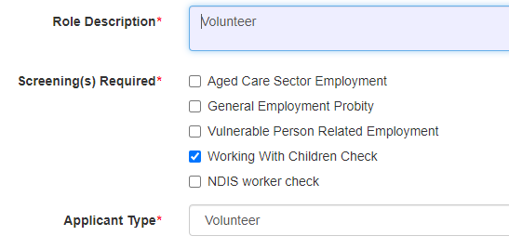

1. You must complete and submit your application within 28 days or your application will be deleted and you will need to start the application again.

***Site Induction and Welcome***

Our Principal, Chris Edmonds will hold Site Induction and Volunteer Welcome sessions several times each term. Session dates are published in the newsletters, or please contact the front office to check available dates and book a convenient date and time.

***Online courses***

## What you need before you start

* A current individual email address.
* A computer or mobile with an internet connection.
* A recent web browser, such as Google Chrome (50 or later) or Firefox (Internet Explorer is not compatible).

If you do not have access to a computer please contact your local library.

## Register for a Plink volunteer account

* <https://www.education.sa.gov.au/working-us/rrhan-ec/fundamentals-course-responding-risks-harm-abuse-and-neglect-education-and-care>
* Click on – **Create a plink account**
* Fill in your details:
* in the field “Select Account type” select **Volunteer**
* enter your email address (this will be your plink username)
* choose a password
* type in your name and mobile number
* Select “I accept the terms of use and code of ethics”
* Select “Create a plink account”

## Start the training

* Select the course:
  + Responding to Abuse and Neglect-Education and Care (approx 1 hour to complete)
  + Online induction session for volunteers (approx 20 minutes to complete)
  + Protective Practices
* Select “Register”
* Select “Register” again
* Select “Open Module” when you’re ready to start

## Completing the training and share your certificates

Once the training is completed you will be issued with a certificate. The certificate saves automatically on the computer’s ‘Desktop’ or the ‘My Documents’ folder.

Please provide a copy of the certificate to the Front Office.

**If you need help please email** [**decd.plink@sa.gov.au**](mailto:decd.plink@sa.gov.au) **for technical help.**